**Phase 6: User Interface Development**

**Lightning App Builder:**

Created the Orderly App in App Manager. Configured branding, navigation, and utility bar. Assigned to administrator profile.

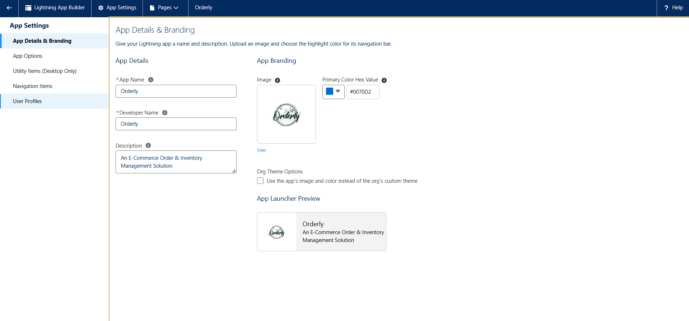

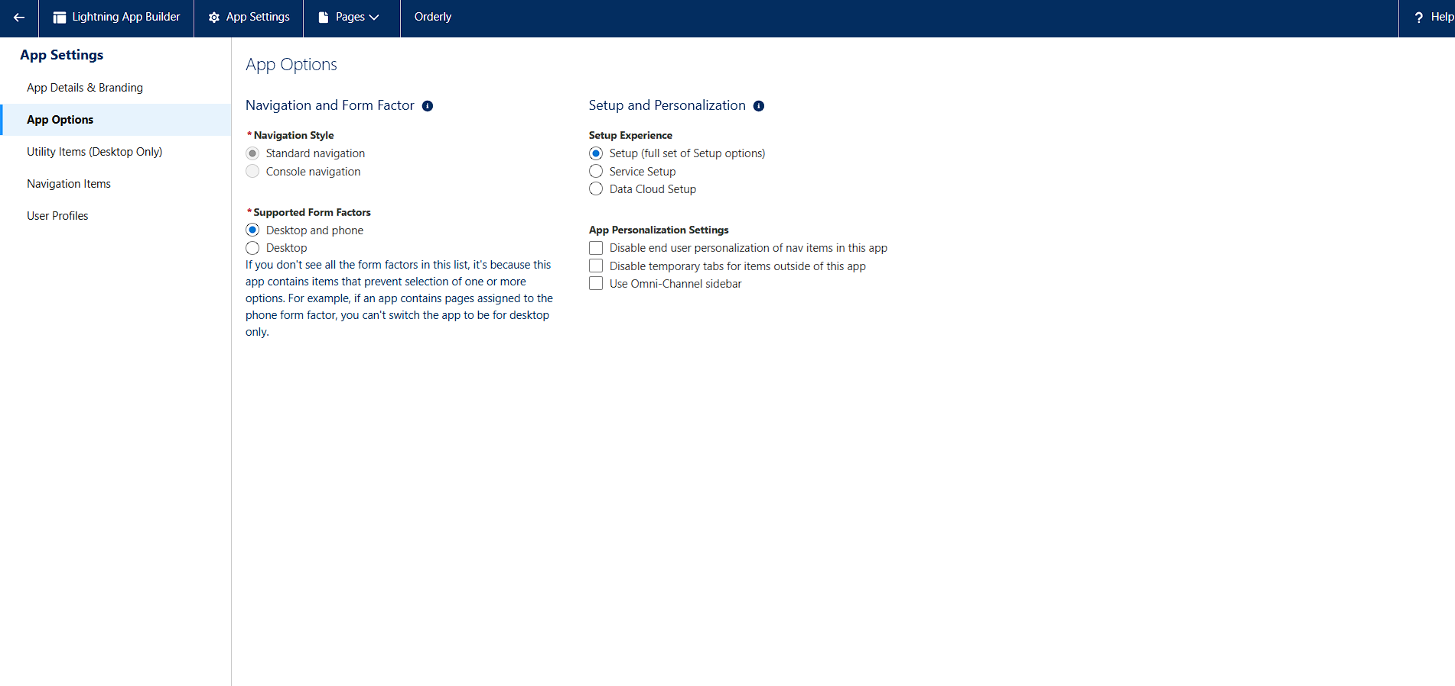

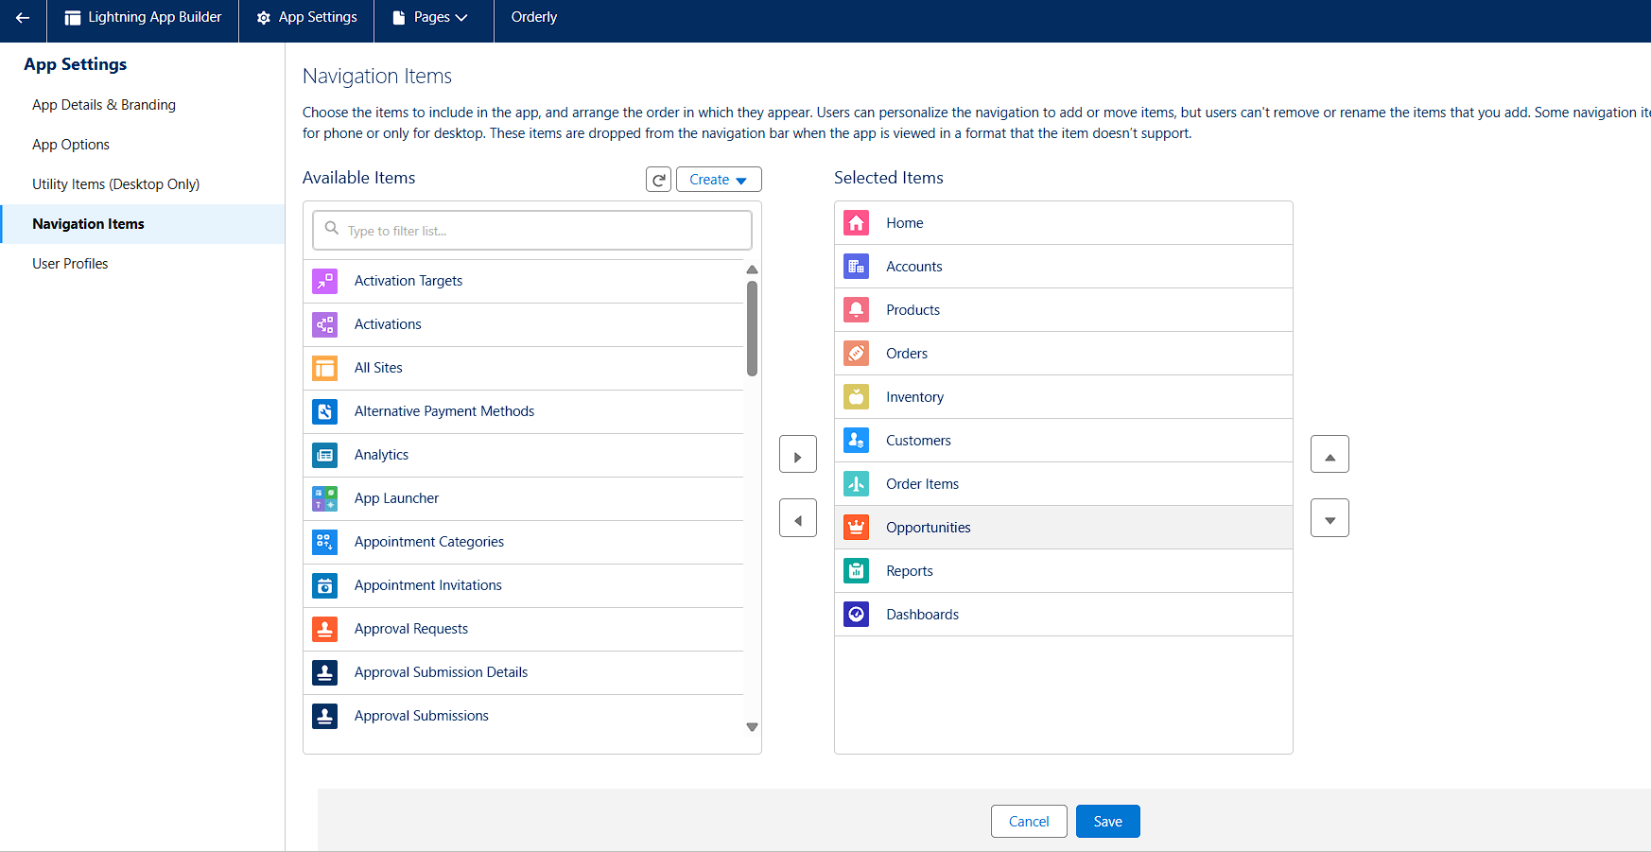

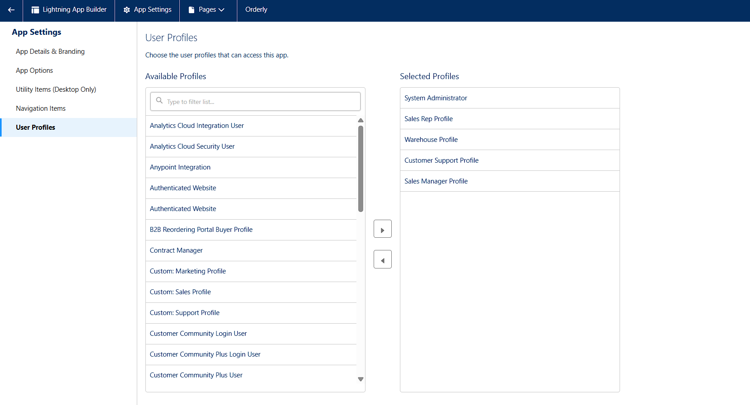

**Record Page:**

Custom record pages built for Orders, Products, and Inventory. Added Highlights Panel, Record Detail, and Related Lists components.

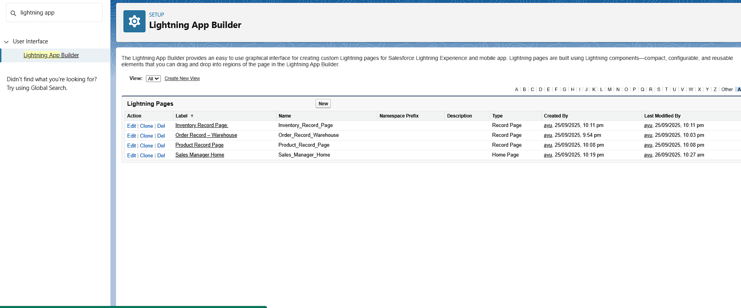

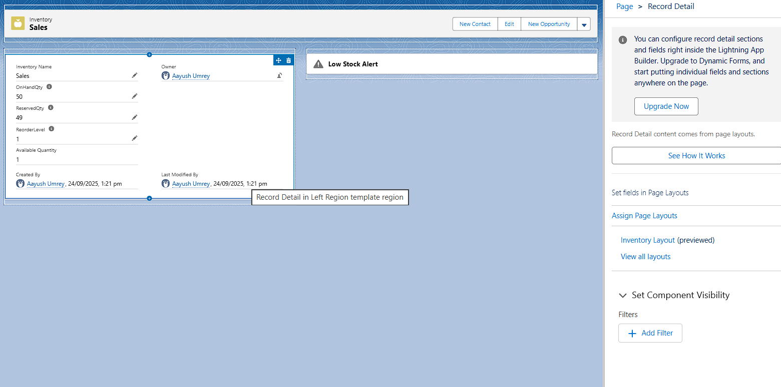

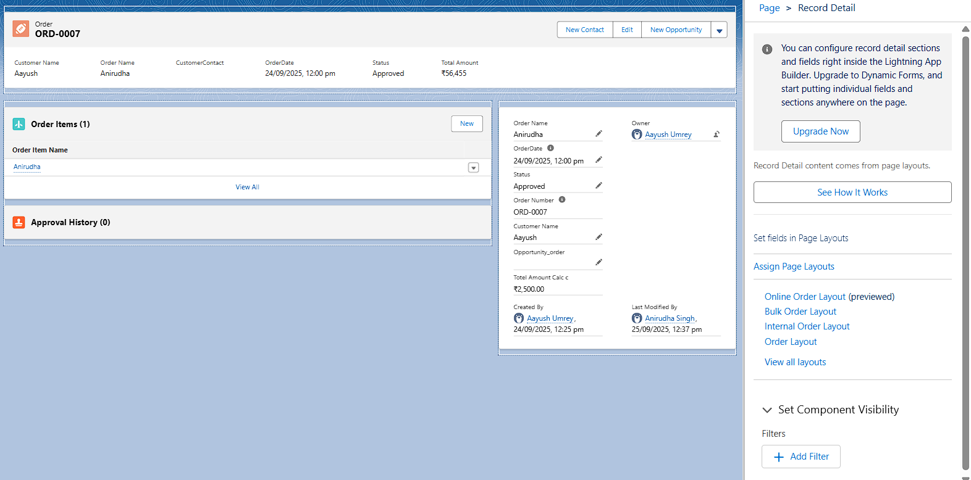

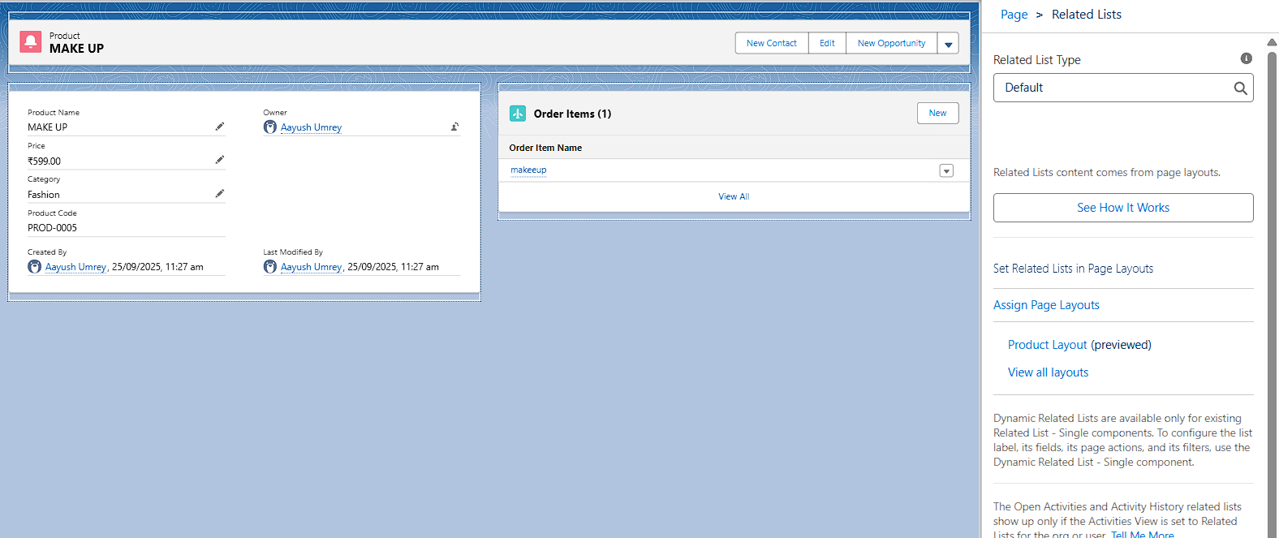

**Tabs**

Tabs created/verified for Orders, Products, Customers, Inventory, Order Item, ect.



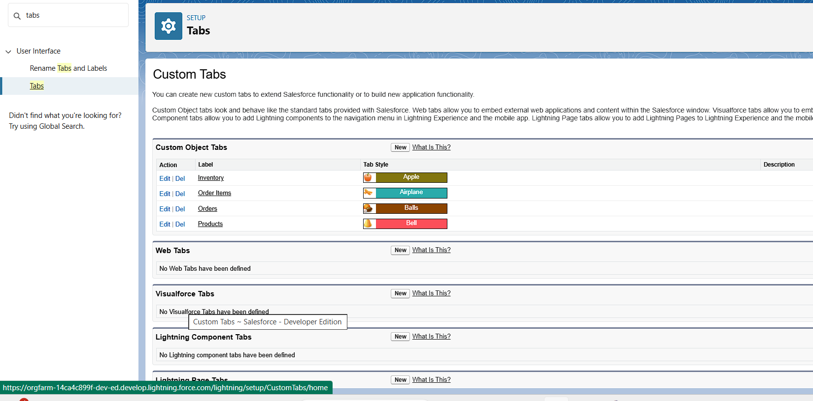

**Home Page Layouts:**

Designed custom Home Page using Lightning App Builder with Performance, Task , Recent Record, Low stock alert and Dashboard components.

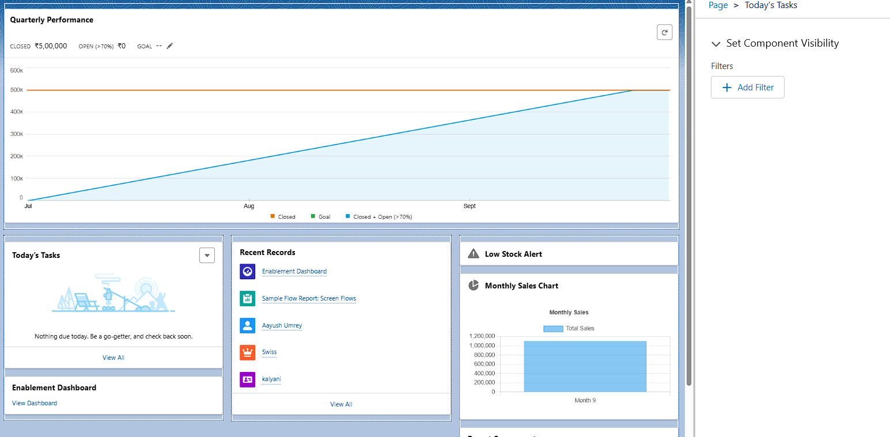

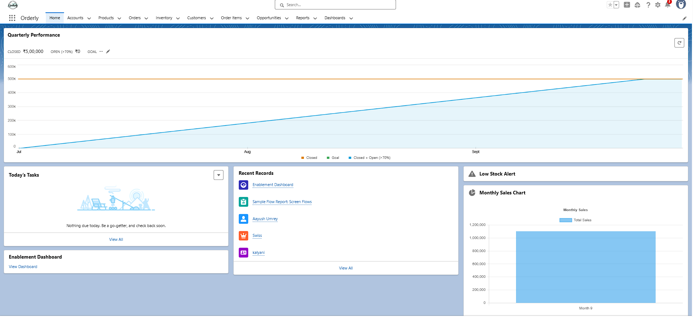

**Utility Bar**

Configured Utility Bar with quick access to Recent Items, Notes, Chatter Feed, and Report Charts.

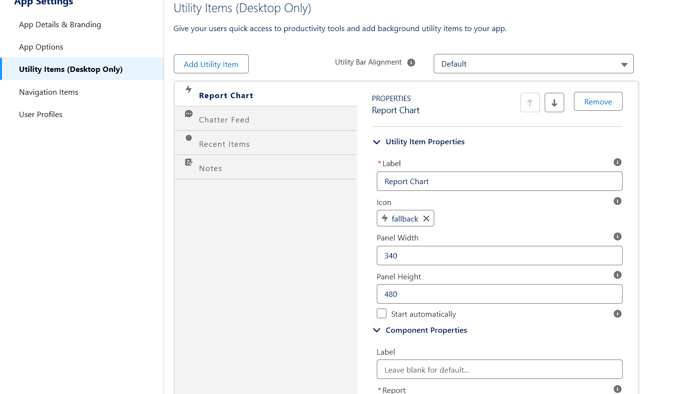

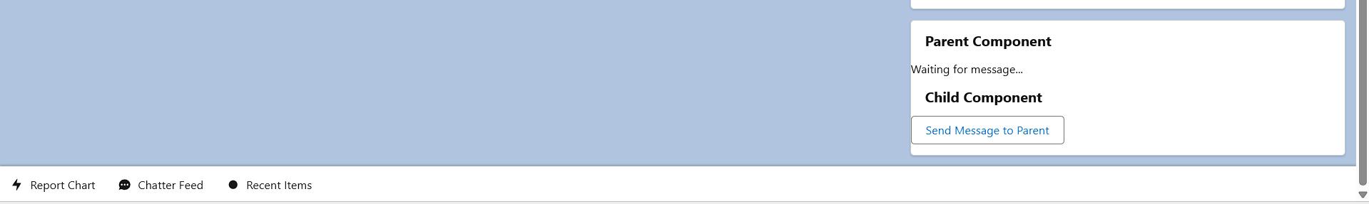

**LWC (Lightning Web Components):**

Developed LWCs: lowStockAlert, ParentComponent, ChildComponent, produceSalesChart.

Purpose: Display recent Low Stock,saleschart.

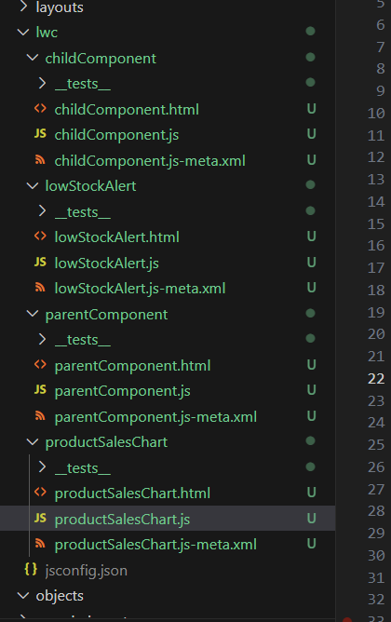

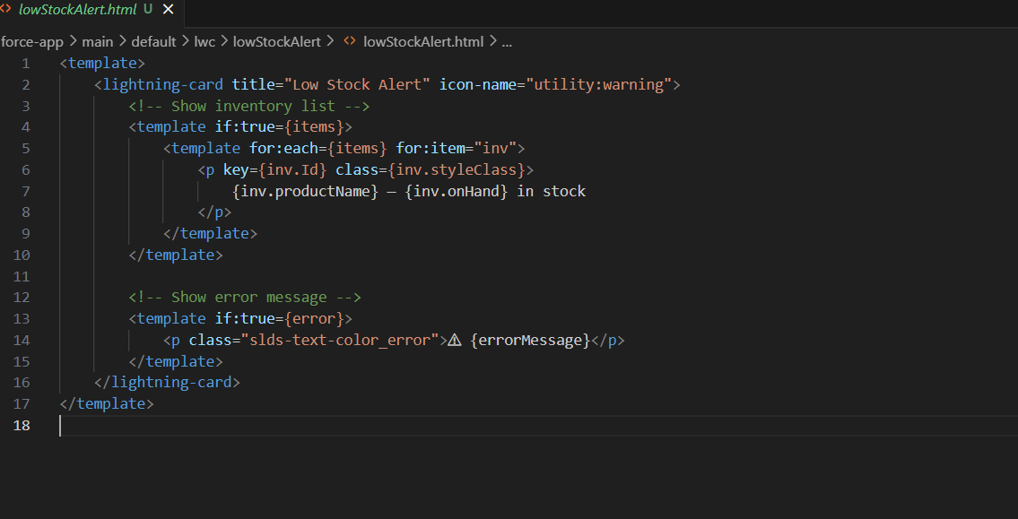

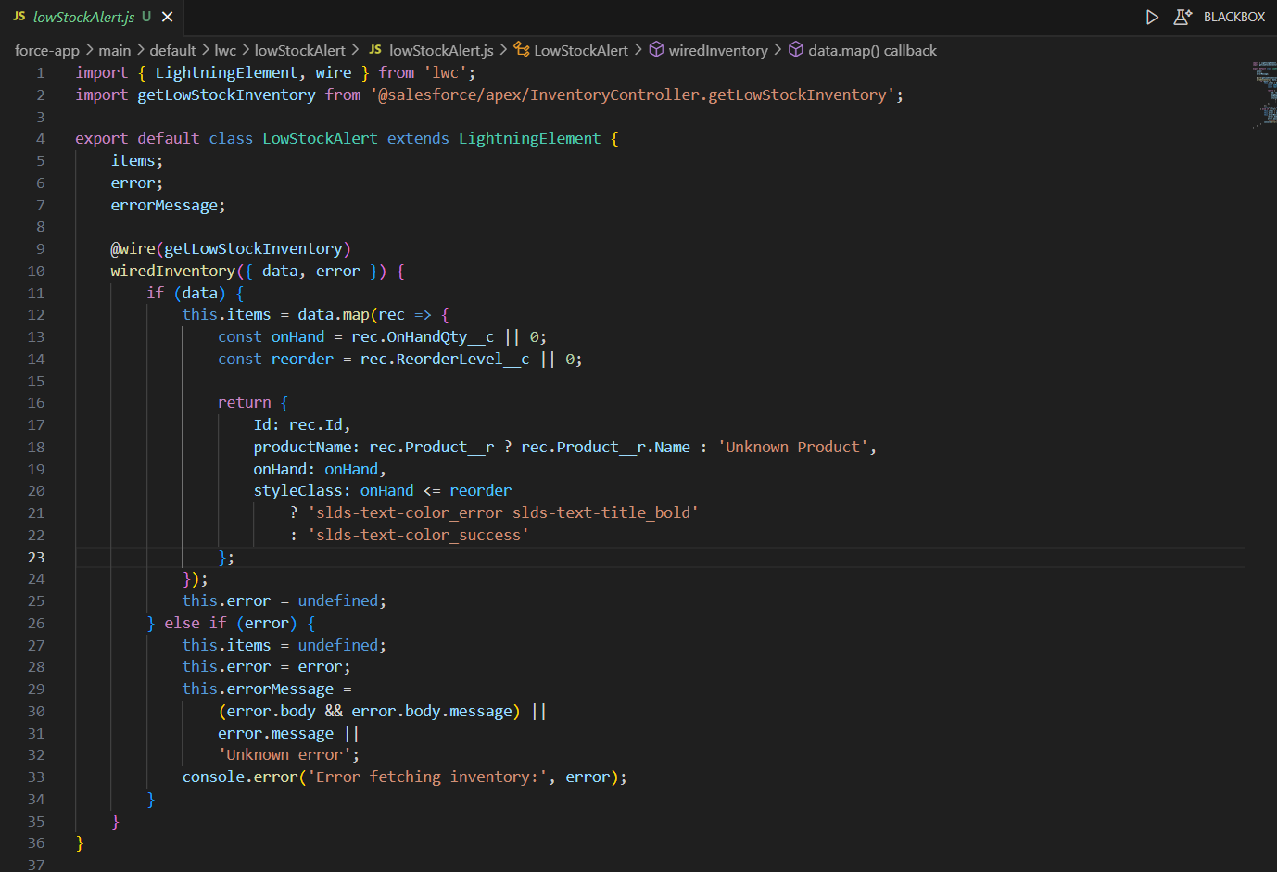

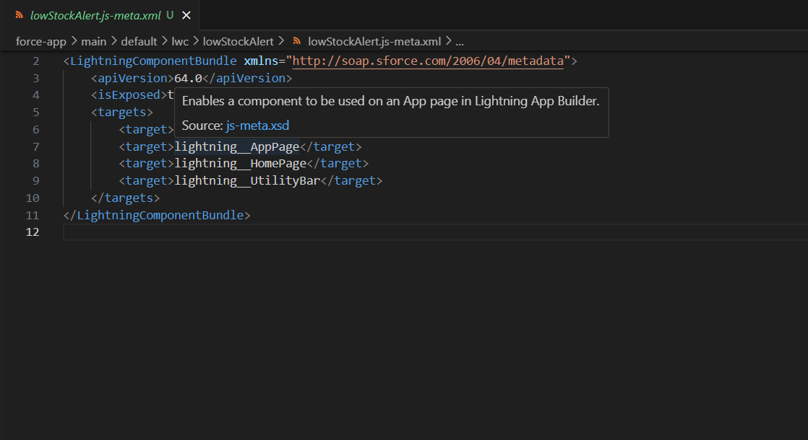

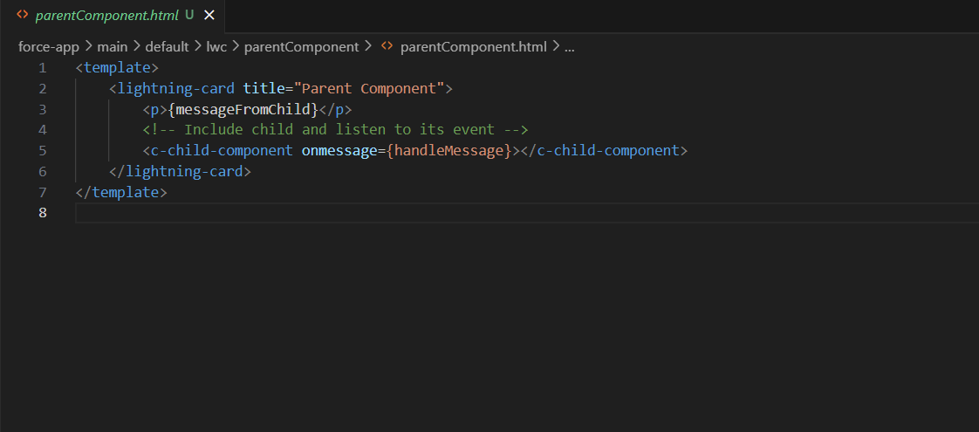

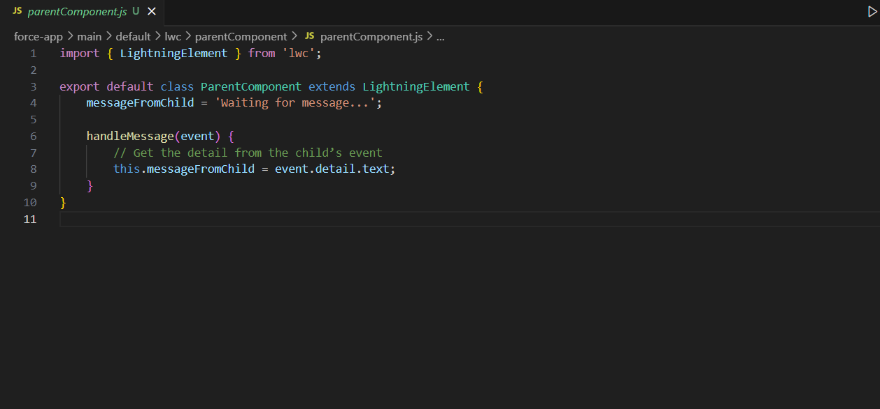

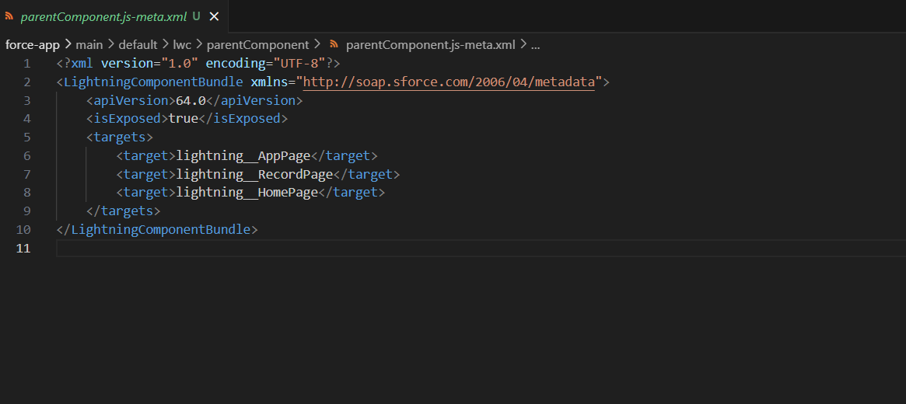

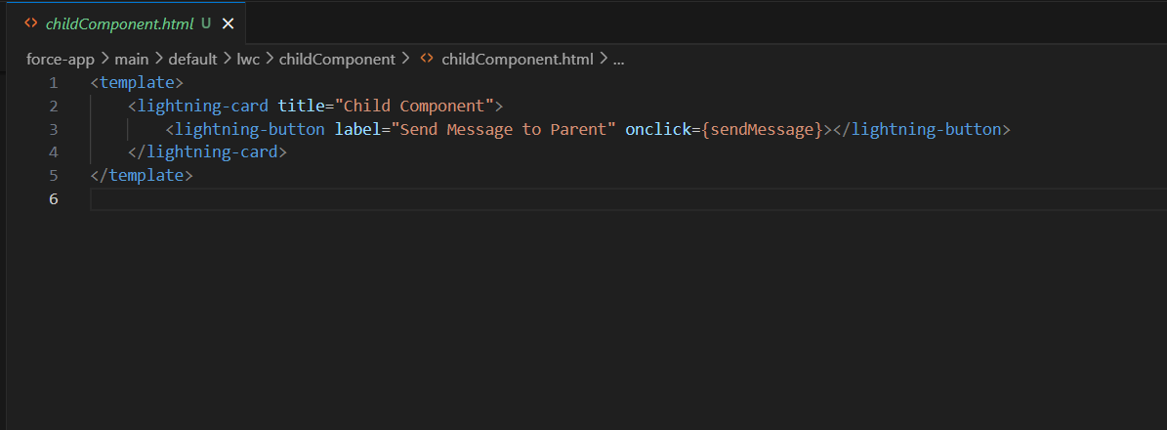

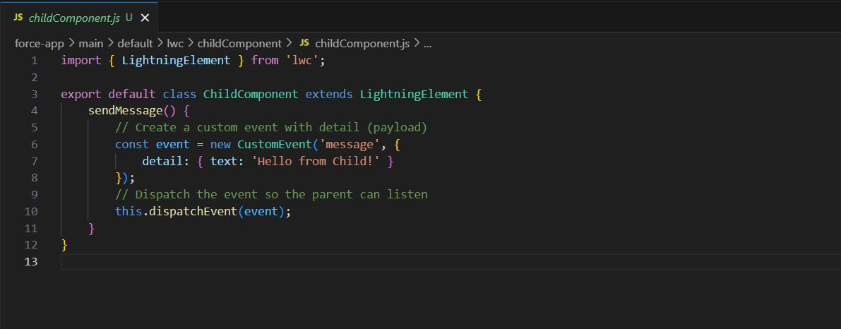

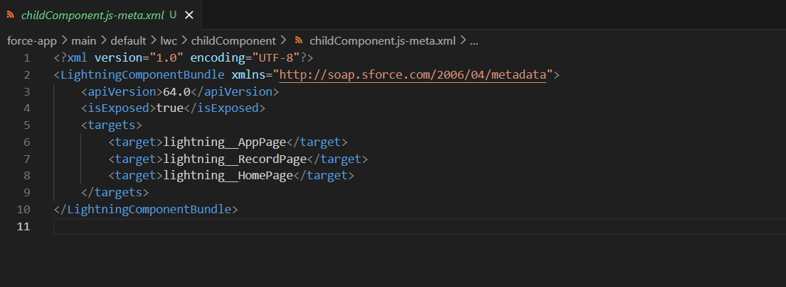

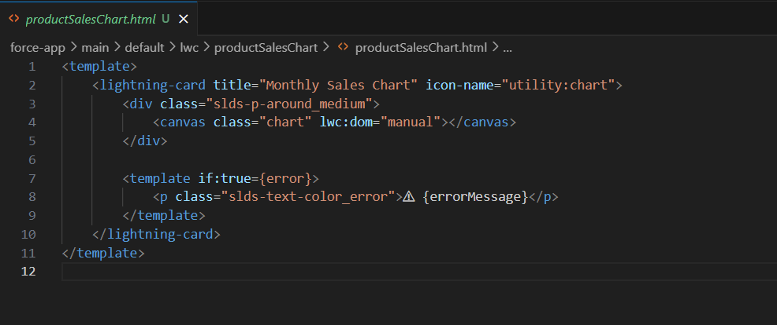

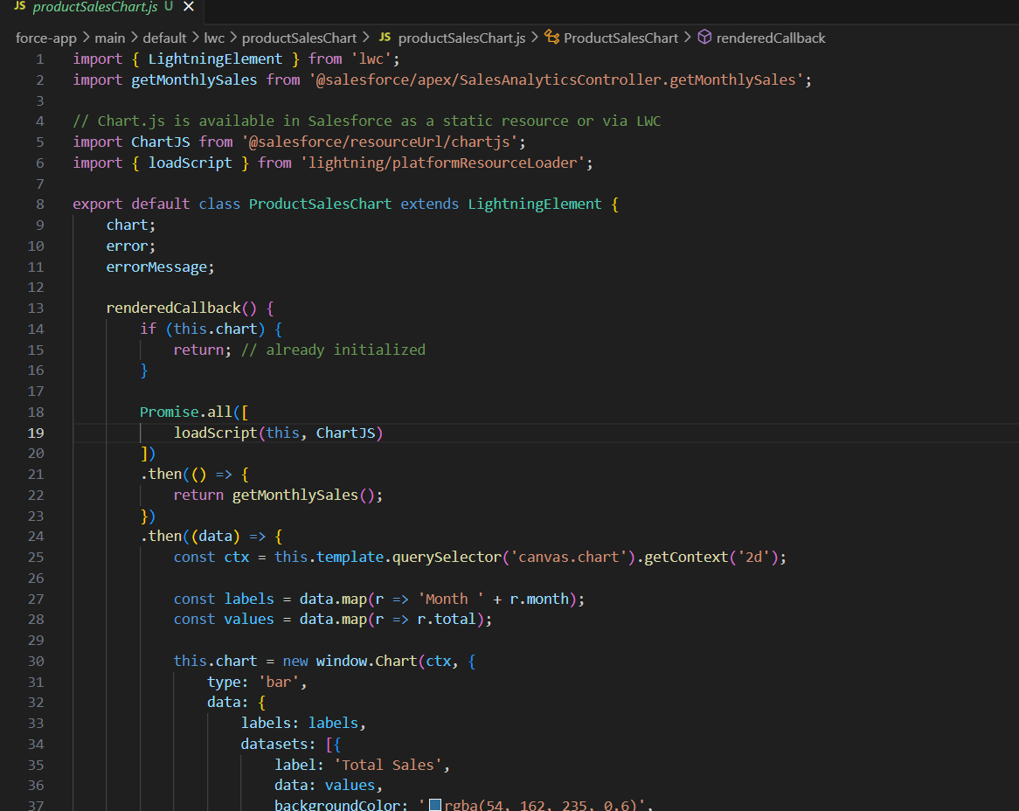

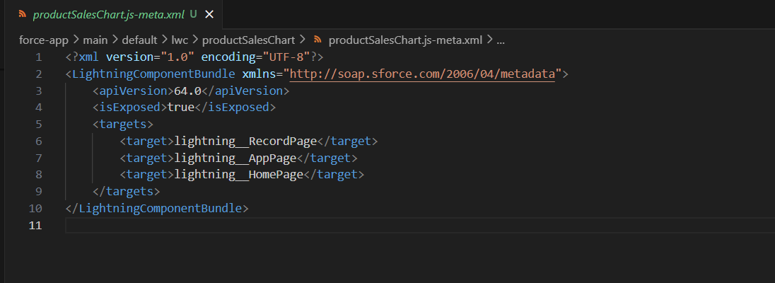



**Events in LWC:**

We have implemented custom event in LWC.













**Wire Adapters:**

Wire adapter is used in lowStockAlert. To alert the manager as we are going low stock.

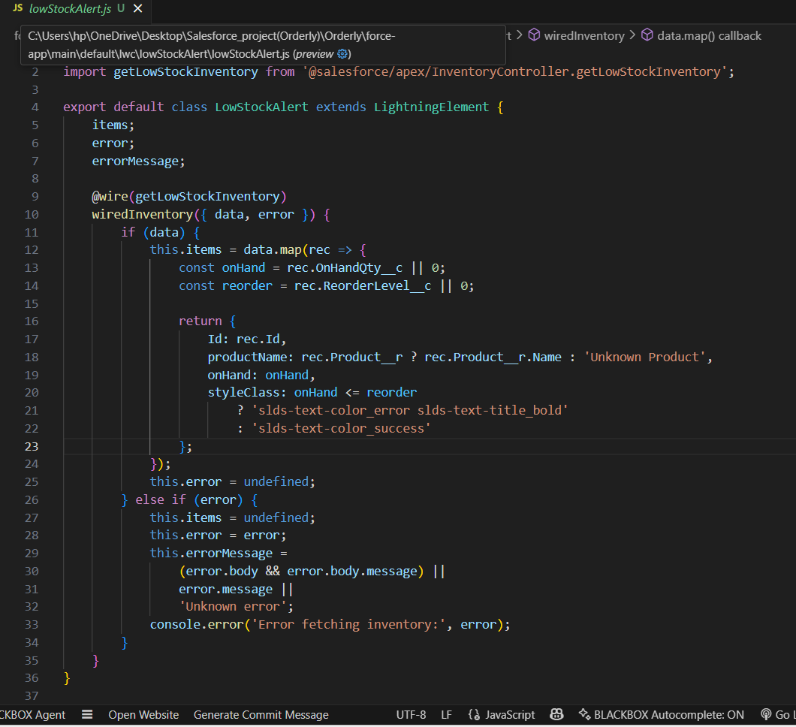

**Imperative Apex Calls:**

Imperative Apex Call → manual, on-demand data fetch (used in ProductSalesChart).

